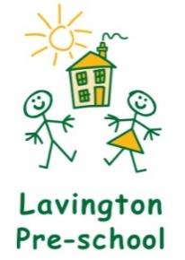

TERM DATES & FEES 2023- 24

Term 1: 5th September to 18th October
Half Term: 19th October – 29th October
Term 2: 30th October – 20th December
Winter Break: 21st December – 3rd January
Term 3: 4th January – 8th February
Half Term: 9th February – 18th February
Term 4: 19th February – 28th March
Spring Break: 29th March – 14th April
Term 5: 15th April – 24th May
Closed Bank Holiday Monday 6th May
Half Term: 25th May – 2nd June
Term 6: 3rd June – 24th July
Summer Break: 25th July – 31st August

Please note that DAPS has TD Days on the following dates but the Pre-school will be open : 18/10/2023, 19/02/2024, 03/06/2024 and 24/07/2024

Fees
Our fees for 2023 - 2024 are: 3-5yr olds 2yr olds
£5.50 per hour £5.95 per hour
All children qualify for 15 hours Free Entitlement and may be eligible for 30 hours funding in the term after their 3rd birthday. If your child’s 3rd birthday is between 1st Sep-31st Dec, they will qualify for childcare funding from the start of spring term, if your child’s 3rd birthday is between 1st Jan-31st Mar, they will qualify for childcare funding from the start of summer term, if your child’s 3rd birthday is between 1st Apr-31st Aug they will qualify for childcare funding from the start of autumn term. From April 2024 working parents of 2 year olds may qualify for 15 hours per week funding. More information can be found here: Childcare Choices | 30 Hours Free Childcare, Tax-Free Childcare and More | Help with Costs | GOV.UK

Wrap-around Care
8.30am – 9.00am 8.45am – 9.00am 3.00pm – 3.10pm
£3.00 per day/per child £1.50 per day/per child £1.00 per day/per child

Snack £1.00 per day/per child

Please note you are unable to use your Free entitlement or 2-year-old funding to cover wrap-around care session costs.

