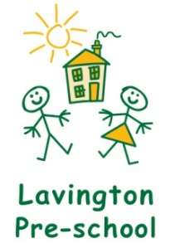

In the event the Government closes schools and pre-schools or you are in self-isolation, we have made a list of activities to help keep your children busy which are linked to the seven areas of the Early Years Foundation Stage.
Many of these activities should be able to be done without needing to buy any resources. We have tried to make them open and flexible.
This is not a tick list for you to work down, choose your favourites and do them as many times as you like – repeating them is good!
Julie Langlands
Manager Lavington Pre-school

Personal, Social and Emotional Development
- Massage – pretend to make a cake or build a pizza on your partner’s back
- Share stories – retell and act them out
- Make bread together
- Chop the vegetables for dinner together
- Give your children responsibility to help with household chores – spray the window cleaner and clean the windows is a favourite!
- Look at Cosmic Kids Yoga on YouTube and join in together
- Sharing a family meal and talk about your day
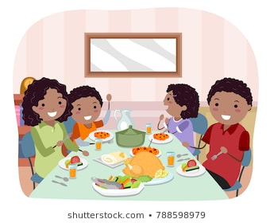

Physical Development
- Threading pasta on to wool or string
- Water play in the bath – scooping, pouring and measuring
- Design a treasure hunt around the house
- Junk modelling
- Make playdough together https://www.youtube.com/watch?v=jv73CEzY1jg This is how!
- Musical movement games – like musical statues
- Lego and block play. Plan to build something and see if you can follow your plan
- Make sensory tray with shaving foam, soap, jelly etc
- Painting with water in the garden
- Phonics and dancing with Boom Shake the Alphabet https://www.youtube.com/results?search_query=boom+shale+the+alphabet
- Rough and tumble play
- Building dens and tunnels with blankets and under the kitchen table
- Watch episodes of ‘Come Outside’ on YouTube
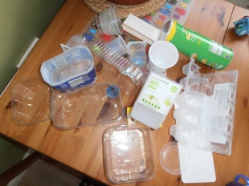

Communication and Language
- Storytelling with homemade puppets – use old socks, lolly stick and straws
- Singing nursery rhymes and action songs, such as Simon Says
- Make music with saucepans and pots
- Play guessing games – such as think of an animal and model giving clues to help your child guess the animal
- Play board games
- https://wetalkmakaton.org/ - Learn to sign the Makaton Sign of the Week
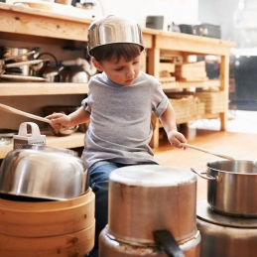

Maths
- Pairing socks
- Playing Snakes and Ladders
- Bigger and Smaller games – describing the 3 Billy Goats Gruff or using Goldilocks
- Add numbers to pegs and the help your child to order them
- Measuring ingredients to cook/ help make dinner
- Sing number songs, such as 5 currant buns or the Everybody Get Up counting song https://www.youtube.com/watch?v=aKvgwVAGSgw
- Sorting toys by colour or shape
- Sorting coins
- Build train tracks in different shapes
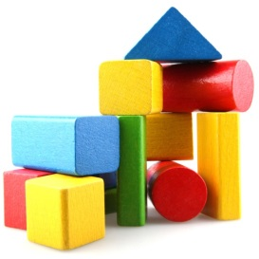
- Build towers from blocks – how many blocks did you use? Can you use the same blocks to build a different tower?
- Make a bowling game with toilet rolls

Literacy
- Share story books and talk about what is happening on each page
- Play lotto games – matching pictures
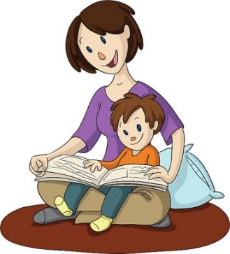
- Sing Jolly Phonics songs
- Hide an object in a ‘mystery bag’ and give clues to what might be inside
- Tap out syllables to break up your name on musical instruments

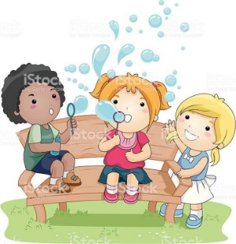
Understanding the World
- Blowing bubbles
- Make bread or pizzas for the family to share
- Read information books on frogs and chicks
- Hunt for bugs in the garden
- Use Nature Detectives for lots of exciting activities to do at home: https://naturedetectives.woodlandtrust.org.uk/naturedetectives/
- Planting seeds such as cress – and watching them grow
Look at science experiments for Early Years https://www.firstdiscoverers.co.uk/early-years-science-activities-eyfs/
- Observe the weather each day and make a weather chart
- Make a family tree – who is in your family
- Freeze small toys in ice – and work out how to get them out of the ice
- Make a rainbow of skittles sweets around the edge of a small plate – add warm water and watch a rainbow appear.
- Look for different sorts of ICT in your home eg, microwave, remote control, phone etc
- Feed the birds in the garden and keep a tally of which birds visit your garden
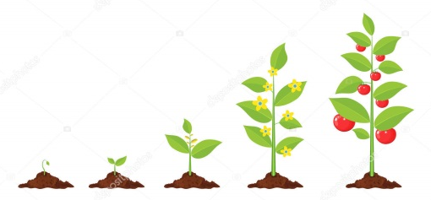
- Make seed bombs by mixing seeds with clay to make a small ball. Dry them out and wrap to give as presents. Make a label to attach.

Expressive Art and Design
- Dancing to music – use scarves
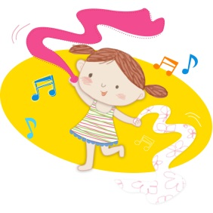
- Sing familiar songs and make up your own words to nursery rhyme tunes
- Make shakers with pasta or rice in pots
- Make your own paint with shaving foam or coloured ice
- Make props for your favourite story and act it out together

Handwash Song
Happy birthday to me
Happy birthday to me
Happy birthday dear me
Happy birthday to me (sung twice)

