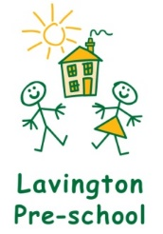

Lavington Pre-school’s Aim and Values

Our Aim is to provide high quality learning experiences through play, in a safe, secure and stimulating environment within the framework of the EYFS preparing the children for school readiness.

Our Values are:
- Each child is a unique individual.
- Parents are their child’s first educator.
- Positive relationships and working in partnership.
- Diversity and promoting equalities.
- Developing respect for each other and the environment.

